Subscription Permissions
Managing your subscription permissions is done by simply selecting yes or no for usergroup access. If you click Paid Subscriptions > Subscription Permissions, you will see a screen similar to this:
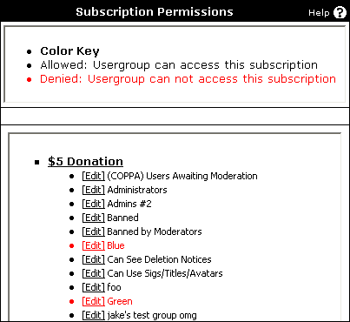
Here, you will see each subscription on your forum with a list of all usergroups under each forum. Notice the color key at the top. In this example, red indicates that a usergroup does not have permission to purchase the subscription. Otherwise, usergroups listed in black have access to purchase the subscription.

To edit a subscription, simply find the appropriate subscription and usergroup, and click [Edit]. This will lead you to this screen:
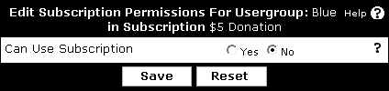
To deny access to purchase a subscription, choose No, otherwise choose Yes to allow permission.

